The Building Case Against COVID-19 Vaccination of Students in Canada

Scientific and Medical Advisory SubCommittee:

Byram Bridle, MSc, PhD, Associate Professor, Dept. of Pathobiology at the University of Guelph
Philip Britz-McKibbin, PhD, Professor, Dept. of Chemistry and Chemical Biology, McMaster University
Glen Chan, BAA, Patient Advocate
Claudia Chaufan, MA, MD, PhD, Associate Professor, Health Policy, York University
John Hardie, BDS, MSc, PhD, FRCDC (retired)
Ondrej Helgas, MSc, PhD
York Hsiang, MB, MHSc, FRCSC, Professor Emeritus, Dept. of Surgery, University of British Columbia
Niel Karrow, PhD, Professor of Immunology, Dept. of Animal Biosciences, University of Guelph
Bonnie Mallard, Msc, PhD, Professor of Immunogenetics, Dept. of Pathobiology, University of Guelph
Kanji Nakatsu, PhD, Professor Emeritus Pharmacology, Queen's University
Philip Oldfield, DPhil, CSci, CChem, FRSC (UK) (retired)
Steven Pelech, PhD, Professor, Dept. of Medicine, University of British Columbia
Patrick Provost, PhD, Professor, Faculty of Medicine, Université Laval
Denis Rancourt, PhD, Former Professor, University of Ottawa
Wendi Roscoe, PhD, Professor, Dept. of Health Science at Fanshawe College
Christopher A. Shaw, PhD, Professor, Dept. of Ophthalmology, University of British Columbia
David Speicher, MSc, PhD, Former Associate Professor, Biology and Health Sciences – Redeemer University

May 1, 2023

Corresponding author: Steven Pelech, spelech@mail.ubc.ca
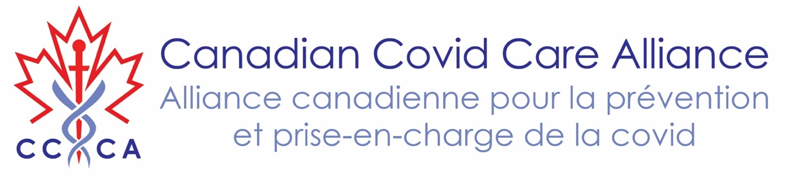

Summary
When the risk-benefit, ethics, broader legal, natural immunity prevalence and informed consent implications of COVID-19 vaccinations are fully considered, mandating booster shots for healthy students in 2023 cannot be endorsed, regardless of recommendations or directives from federal and provincial health authorities or professional health colleges in Canada and abroad. Some universities in Canada are contemplating requiring or already mandate that students who are enrolled in health profession training schools are fully up to date with their COVID-19 vaccinations. In view of the availability of a wealth of data questioning the efficacy and safety of COVID-19 genetic vaccines, and the actual threat that COVID-19 possesses with respect to the morbidity and mortality of youth and working age adults, such requirements are irresponsible and border on criminal negligence. This is particularly concerning given the alarming increase in excess mortality in Canada since the beginning of 2021, with paradoxically more COVID-19 related deaths and hospitalization in 2022 relative to 2021, despite the high primary series and booster vaccine coverage. Furthermore, it is evident from numerous serological studies that natural immunity from past infection with SARS-CoV-2 already exists in the vast majority of Canadians, and the latest variants of this virus are much less virulent and less likely to cause severe COVID-19 in children and adults. The Scientific and Medical Advisory Committee of the Canadian Covid Care Alliance strongly recommends against any future mandates of COVID-19 vaccination of students in primary, secondary and post-secondary schools and institutions.

Introduction
Presently, students in Canadian universities in health professional schools or residents on campuses are required to receive certain vaccinations that might include COVID-19 vaccines. COVID-19 vaccines have now been fully recognized to neither prevent infection, nor prevent transmission, and it is also dubious that they even reduce the severity of COVID-19 for the vast majority of those that are vaccinated. This was evident even in 2021, in the truncated placebo-controlled randomized clinical trials for the modified mRNA COVID-19 vaccine prototypes that claimed a relative risk reduction in mild symptomatic disease despite concerns related to data integrity, lack of transparency, and potential scientific fraud, including study unblinding and underreporting of adverse events.1,2 Importantly, these pivotal studies did not measure a reduction in COVID-19 related hospitalization or (all-cause) mortality as primary clinical endpoints in contradiction to misleading public health messaging that mass vaccination was a primary means to end the pandemic, protect oneself and others, and sustain the healthcare system. Yet the risks of severe disease from COVID-19 for working adults is exceedingly low compared to other causes of death, and the threat continues to decline as the SARS-CoV-2 virus has evolved into less virulent Omicron variants that are still 97% identical to the ancestral Wuhan strain with respect to the primary structure of the spike protein of the virus.
For instance, Statistics Canada in their analysis of all-cause mortality reported only 2 and 90 deaths with/from COVID-19 for those 19 and under and those 20-44 years old, respectively, representing 0.18% and 0.69% of all-causes of their mortality in 2020.3 In both age groups, there were more deaths attributed to influenza/pneumonia, with accidents/unintentional drug overdoses, suicides, cancer, heart disease, assault and diabetes being far more consequential for most young adults and children (~ 65% of all deaths). In fact, infectious diseases amount to only about 2.3% of all fatalities for those under 44 years of age, reflecting the primacy of poor metabolic and mental health in the population. Draconian state-enforced COVID-19 medical countermeasures, including lockdowns, social isolation and fear-based narratives have predictably exacerbated deaths of despair and contributed to delays to chronic disease treatment/screening, thus harming an otherwise younger demographic and contributing to an unprecedented loss in quality-adjusted life years. In fact, all real-world indicators of health and well-being, including the incidence of chronic diseases, obesity, mental health and drug addiction, have worsened since declaration of the COVID-19 pandemic in March 2020 with both older and younger Canadians dying at higher rates in spite of an aggressive roll-out of COVID-19 vaccines.
COVID-19 genetic vaccines specifically lead to the production of a viral spike protein by the body’s own cells on their surface to elicit an immune response. These modified mRNA encapsulated in lipid nanoparticles act as ‘pro-drugs’ and spread well beyond the site of injection with highly variable biodistribution, dosage, and pharmacokinetics, and lead to prolonged expression of a functionally toxic and extinct version of the SARS-CoV-2 virus spike protein throughout the body. Over 84.5% of Canadians over 5 years of age have already been vaccinated at least twice, although less than 20% have been vaccinated for COVID-19 in the last 6 months.4 This reflects increased ‘vaccine skepticism’ by most Canadians given ever changing definitions of what constitutes being fully vaccinated as it requires an indefinite number and variable timing of serial injections of liability-free formulations that make a mockery of the principles of evidence-based medicine and biomedical ethics. Public health officials, and other pandemic enthusiasts and soothsayers, continue to raise doubt of the durability of infection-related immunity, foresee the emergence of more virulent strains, or speculate that boosters may help reduce long COVID-19 symptoms.5 As described later, over 90% of the Canadian population has apparently had one or two infections with SARS-CoV-2 and have acquired natural immunity independently of COVID-19 vaccination. In fact, herd immunity was never attainable via the non-sterilizing, modified RNA injectables. Clinical studies of vaccine-induced immunity relied solely on primarily circulating antibody titers, which are poor surrogate indicators of mucosal immunity. Early stages of (re)infection against respiratory viruses and protection are well known to also be mediated by resident memory pulmonary T-cells.6
The use of COVID-19 genetic vaccines has led to reports of death within days following injection, as well as permanent disabilities and severe injury in a significant portion of otherwise healthy recipients. Such significant side-effects include initially increased risk of COVID-19, severe allergic reactions, myopericarditis, thrombosis, thrombocytopenia, heart attacks, Guillain-Barré syndrome, Bell’s palsy, shingles, menstrual irregularities, over a thousand other disorders. Such adverse events have been documented by Pfizer’s own literature and pharmacovigilance surveillance databases in the USA (VAERS), Australia (AusVaxSafety), the United Kingdom (YellowCard), the European Union (EudraVigilance) and the World Health Organization (VigiAccess).
The potential harms of these vaccines now clearly outweigh their benefits for students. This has become recognized by the regulatory health agencies of many other countries, several of which no longer recommend COVID-19 vaccination (especially for children and young adults). Fortunately, at this time, few universities in Canada require mandatory COVID-19 vaccination for their students and staff, even if they train or work in hospitals and clinics. However, some universities, such as the University of British Columbia and Dalhousie University, do have such requirements even with clear serological evidence of a past COVID-19 infection. For other infectious diseases, such as hepatitis, vaccination is not required if a person has demonstrated immunity, which is indicated by the presence of antibodies against the responsible virus. Such a situation should apply to the vaccination policies of students enrolled in medicine, nursing, mid-wifery, dentistry and any other schools that involve training of future health professionals if there is still a justified need for demonstrated immunity from COVID-19.
The justification of these requirements for certain university students has been that the provincial health authorities do or might require such vaccination policies, and that the faculties of these schools intend to be fully compliant in order that students will be able to complete their training in a hospital or other clinical setting. However, as evidence-based institutions that often inform provincial health authorities on such crafting policies, the issue arises whether it is ethical to force prospective and current students to relinquish their body autonomy for a practice that is unnecessary, lacking in efficacy and potentially damaging to these students. After 13.4 billion COVID-19 vaccine doses have now been injected in about 70% of the world population,7 even Dr. Anthony Fauci, originally Director of the US NIH National Institute of Allergy and Infectious Diseases, has acknowledged the urgent need to rethink the design of next-generation vaccines for coronaviruses, influenza viruses and other respiratory viruses since “durably protective vaccines against non-systemic mucosal respiratory viruses with high mortality rates have thus far eluded vaccine development efforts.”8 This admission of failure highlights that current COVID-19 genetic vaccines were and still are investigational prototypes rather than authentic pharmaceutical products subject to full regulatory oversight, normal manufacturing standards, stringent quality control, and past accepted manufacturer liability.

Key Points:
- Post-secondary students have always been at very low risk of severe COVID-19.
- COVID-19 vaccines do not prevent transmission and therefore do not protect anyone else from secondary infection, i.e., they do not stop the spread of COVID-19.
- Most provincial governments in Canada (e.g., Alberta, Ontario and Quebec), hospitals, long term care facilities, colleges and universities are no longer mandating COVID-19 vaccines.
- COVID-19 genetic vaccines can cause serious and long-lasting adverse events, including death at rates that are unacceptable by previous standards for vaccines.
- Natural immunity is widespread, more effective and longer-lasting than vaccine-induced immunity.
- People with booster vaccinations appear to have a higher risk of serious SARS-CoV-2 infections with negative efficacy over time.
- There has been an alarming increase in unexplained/sudden deaths and increasing excess deaths in Canada and world-wide that have worsened with continued roll-out of COVID-19 vaccines.
- Case studies, tissue biopsies and autopsy reports documenting systemic biodistribution and expression of spike protein expression in various organs and tissues as probable causes of death and/or injury post-vaccination in young adults and children.

Risk of COVID-19 in Youth and Working Age Adults
Children and working age adults have been and remain at low risk of COVID-19 mortality as shown in Table 1.9 Note that in the early years of the pandemic the deaths included cases with COVID-19, which was not the cause of death but was a comorbidity (these numbers reflected those that died with COVID-19 as well as those that died from COVID-19). Public Health Ontario data indicates that less than half of COVID-19 recorded deaths were not due to COVID-19, but were from pre-existing comorbidities.10 Note that percentages of hospitalization, ICU admissions and deaths are actually much lower than shown by at least 4-fold, since over 75% of COVID-19 cases are believed to be unreported.11 Moreover, Public Health Ontario recently reported that there were 31% and 39% higher rates of COVID-19 related hospitalizations and deaths in 2022 as compared to 2021, respectively, that disproportionally impacted older persons greater than 60 years, including an alarming increase in hospitalizations for infants under 1 year old.12

Table 1. Cumulative risks of COVID-19 cases, hospitalizations, ICU admissions and deaths by age in Canada since the start of the COVID-19 pandemic to April 4, 2023.13 Note that these estimates of death with COVID-19 are much higher in each age group than what is provided by the Statistics Canada website for all-cause morbidity.³

Age Group (Years) | Cases | Hospitali-zations | Hospitali- zations % | ICU Admis-sions | ICU Admis-sions % | Deaths | Deaths %
0-11 | 420,445 | 7,030 | 1.67 | 730 | 0.17 | 53 | 0.013
12-19 | 330,872 | 2,686 | 0.81 | 304 | 0.09 | 26 | 0.008
20-29 | 751,906 | 9,780 | 1.30 | 1,061 | 0.14 | 148 | 0.020
30-39 | 724,380 | 14,522 | 2.00 | 2,000 | 0.28 | 342 | 0.047
40-49 | 636,294 | 15,455 | 2.43 | 3,204 | 0.50 | 710 | 0.112
50-59 | 550,742 | 24,891 | 4.52 | 6,009 | 1.09 | 1,902 | 0.345
60-69 | 364,570 | 37,850 | 10.38 | 8,743 | 2.40 | 4,403 | 1.208
70-79 | 248,814 | 51,186 | 20.57 | 8,372 | 3.36 | 8,111 | 3.260
80+ | 330,938 | 76,112 | 23.00 | 4,667 | 1.41 | 21,113 | 6.380
All groups | 4,358,961 | 239,512 | 5.49 | 35,090 | 0.81 | 36,808 | 0.84

Extent and Effectiveness of Natural Immunity to COVID-19
Natural immunity is widely present in the Canadian14 and international population. For post-secondary students, the prevalence of natural immunity is believed to be even higher than the population at large. Students are highly social and therefore they have been in contact with many people who have carried SARS-CoV-2. Consequently, the vast majority are naturally immune, with better immunity than they would have received from COVID-19 vaccination.

A clinical study undertaken with 276 healthy adults by the British Columbia (B.C.) Children’s Hospital determined that 90% of them had pre-existing antibodies that recognized the spike and nucleocapsid proteins of the SARS-CoV-2 virus by May of 2020, less than half a year into the pandemic.15

A follow-up clinical study with over 4500 people in the clinical study undertaken by Kinexus Bioinformatics Corporation in Vancouver with a 41-marker test that monitors for antibodies against 10 of the SARS-CoV-2 proteins has shown over 90% positive results in the study’s participants, who were primarily from B.C. and Ontario.¹⁴

Ichor Blood Services recorded around 89% positive SARS-CoV-2 spike protein antibody results in unvaccinated people in late 2021 prior to the Omicron wave, even in rural areas in northern Alberta with lower population densities.16 With such high rates of natural immunity in remote rural settings, it is reasonable to expect comparable or even higher rates in urban, higher density settings.

In B.C., using a serological test for antibodies against only the nucleocapsid protein of SARS-CoV-2, the B.C. Centre for Disease Control (BCCDC) reported that by August 2022, at least 70-80% of children ≤19 years, 60-70% of adults 20-59 years, but only ~40% of adults ≥60 years had been infected.17 Note that as many as half of the people that are infected with SARS-CoV-2 do not produce appreciable antibodies against the nucleocapsid protein, so these are underestimates.¹⁴

The most recent update from Statistics Canada reported that 98% of Canadians had antibodies against SARS-CoV-2 as of August, 2022, of which 55% had clear serological evidence of natural infection from the detection of nucleocapsid-reactive antibodies.18 Nearly 42% of these Canadians were asymptomatic and never realized that they had already been infected.

Natural immunity from a SARS-CoV-2 infection is at least as protective as vaccination against severe illness and death.19 It lowers risk of severe outcomes by 76% compared to vaccine-acquired immunity at 1 year.20
Natural immunity results in the production of secreted IgA and IgM class antibodies in the upper airways and lungs, which effectively protects again a respiratory virus infection. These antibodies can target most of the 28 proteins found in the SARS-CoV-2 virus.¹⁴ Natural immune protection can last from years to decades, as evidenced with SARS-CoV-1 infection and antibody detection 20 years later with a COVID-19 vaccine booster shot.21

Efficacy of COVID-19 Vaccines
The most commonly used COVID-19 vaccines use lipid nanoparticles to deliver a genetically engineered and modified mRNA payload that would in turn elicit the production of SARS-CoV-2 spike protein. These modifications (such as replacement of uridine with N1-methyl-pseudouridine) permit extra stability of the spike mRNA gene. Following entry into the body’s own cells, this modified mRNA allows for the manufacture of the spike protein and its presentation on the cell’s external surface. The stimulation of B-lymphocyte cells to produce antibodies and T-lymphocyte cells to provide adaptive immunity requires an inflammatory attack against the vaccine recipient’s own cells, which can lead to tissue damage. This requirement for cellular damage is rarely acknowledged in publications that describe the mechanisms of action of COVID-19 genetic vaccines. Only fragmented pieces of the spike protein presented by antigen-presenting immune cells along with major histocompatibility antigens on these intervening immune cells are able to evoke the full simulation of receptive B- and T-cells following their interaction typically in lymph nodes.

Tens of trillions of lipid nanoparticles may be injected with each vaccination inoculation, and 5 to 10 copies of the spike mRNA gene might be present in each lipid nanoparticle. Potentially hundreds of copies of the spike protein can be produced from each mRNA gene. This results in high titer production of spike protein antibodies in the blood of vaccine recipients, which are primarily of the IgG class. However, these IgG antibodies are present at much lower concentrations in the upper airways and lungs. Consequently, the protection provided from mRNA vaccination is considerably less than the protection from a natural respiratory infection, which produces more IgM and IgA antibodies in the most appropriate locations.
Since mid-2021, it has been appreciated that the mRNA vaccinations do not prevent one from contracting COVID-19. For example, in July, 2021, Barnstable County in Massachusetts experienced an outbreak of COVID-19 in which 74% of those testing positive for the SARS-CoV-2 virus were considered fully vaccinated with two doses of COVID-19 vaccine.22 This experience has been replicated around the world and it has been acknowledged publicly by the US NIH’s Anthony Fauci,23 the US CDC’s Rochelle Walensky24 and Pfizer executive Janine Hall25 in 2022, that COVID-19 vaccination does not “stop the spread.” This information about these “leaky” vaccines means that vaccination does not protect others from contracting COVID-19. Therefore, it is not logical nor ethical to force mandatory vaccination upon university students, because such mandates still clearly fail to protect third parties.

There is no difference in the rate of COVID-19 transmission in vaccinated and unvaccinated communities, i.e., vaccination does not prevent transmission of SARS-CoV-2.26 In fact, there have been no formal clinical trials with placebo controls that demonstrate that the COVID-19 vaccines prevent infection or transmission where these conditions have been measured as clinical end-points.

Due to the predominance of less virulent variants of SARS-CoV-2 such as the Omicron variants, and increasing acquisition of natural immunity in the population, it is dubious that the COVID-19 vaccines even reduce the severity of COVID-19. There is no clinical trial evidence to support this assertion. Even in the original 6-month clinical study with the Pfizer/BioNTech COVID-19 vaccine, there were more deaths and serious adverse effects in the vaccinated cohort than the placebo non-vaccinated cohort.27,28

On the BCCDC website, from April 17 to May 14, 2022, hospitalizations and critical care cases per 100,000 were 2-fold higher for the unvaccinated compared with double or triple vaccinated individuals as shown in Figure 1 when adjusted on a per capita basis.29 However, 87% of the BC population had been at least double vaccinated against COVID-19 at this point, so clearly the vaccinations did not prevent or reduce the vast majority of COVID-19 hospitalizations, ICU admissions and deaths in BC. In B.C. in 2022, about 85% of serious COVID-19 cases occurred in those with at least two vaccinations.

Figure 1. Age-standardized hospitalization, critical care and death rates in BC from April 17 to May 14, 2022.²⁹
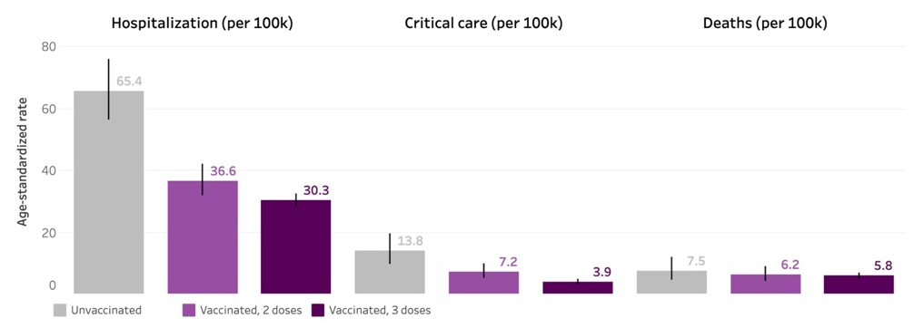

The Omicron bivalent boosters failed to show any benefit above the original Wuhan monovalent COVID-19 vaccine and causes more harm.30 It is noteworthy that the Pfizer bivalent COVID-19 vaccine was approved based on studies with only 8 mice for its efficacy in producing “neutralizing” antibodies that blocked Omicron BA.4 and BA.5 spike protein binding to ACE2, the main receptor to which the SARS-CoV-2 virus binds to cells.31

People with more COVID-19 injections appear to be prone to more SARS-CoV-2 infections.32 This is likely partly due to the innate immune system suppression by SARS-CoV-2 booster vaccinations.33 The long-term effect of repeated immune stimulations with SARS-CoV-2 mRNA vaccines has been associated with a switching from IgG1 and IgG3 isotype antibodies from Th1 helper cells to non-inflammatory IgG2 and especially IgG4 isotypes, which was further boosted with a third mRNA vaccination and/or SARS-CoV-2 variant breakthrough infection(s).34 Such IgG class switching is well known to be associated with the development of immune tolerance from future infections. This translates to negative efficacy against re-infection with future variants of SARS-CoV-2.

Prior vaccination appears to reduce natural immunity following a SARS-CoV-2 infection. Moderna’s 30,000-participant study of persons 18 years or older for its mRNA vaccine showed that subsequent production of antibodies against the nucleocapsid protein of SARS-CoV-2 was evident in only 40% of previously vaccinated participants that later developed COVID-19 compared to 93% of non-vaccinated participants that acquired COVID-19.35 Even a non-vaccinated person with a mild case of COVID-19 had a 71% chance of showing nucleocapsid antibodies in their blood compared to a 15% chance with a vaccinated person that recovered from mild COVID-19.³⁵

Safety of COVID-19 Vaccines

Despite the highly novel nature of the COVID-19 vaccines, these novel products only received about 10% of the typical preclinical and clinical testing of traditional vaccines prior to their general release. Approvals for general release of the COVID-19 vaccines under Interim Order in Canada were given, because it was argued that COVID-19 was particularly deadly and that no other treatments for the disease were officially recognized by Health Canada. It is remarkable that with the Interim Order, Health Canada did not require any evidence that these vaccines were necessarily efficacious or safe.36

However, there have been major issues identified by regulatory agencies in other countries with the testing and production of COVID-19 mRNA vaccines. This is exemplified with the European Medicines Agency review of the Pfizer/BioNTech COVID-19 mRNA vaccine.37 Documents released under Freedom of Information Acts have revealed that the vaccine manufacturers knew early on that their mRNA inoculations showed many significant adverse effects, which were largely discounted. Moreover, there were many factors that were not considered as serious and were also brushed off. For example, the risk of autoimmunity was not explored. Neither were the distribution and pharmacokinetics of mRNA and lipid nanoparticles properly evaluated. Much more important information will be released as interested parties have been analysing the data and text in documents that heretofore have been shielded from public view.38

There are many serious recognized potential harms that arise from COVID-19 mRNA vaccines, such as cardiovascular events (including heart attacks, strokes, and myo/pericarditis), neurological problems such as paralysis, dermatological problems, reproductive issues such as prolonged and heavy menstruation and reduced male fertility, hematological disorders such as blood clots, autoimmunity, hepatic issues, renal issues, respiratory issues, and more than 1200 disorders listed in the six pages submitted by Pfizer,39 as well as those in Table 7 of the 5.3.6 Cumulative Analysis of Post-immunization Adverse Event Reports.40 These Adverse Events of Special Interest (AESIs) included:

• Anaphylactic Reactions
• Cardiovascular AESIs
• COVID-19 AESIs
• Dermatological AESIs
• Haematological AESIs
• Hepatic AESIs
• Facial Paralysis
• Immune-Mediated/Autoimmune AESIs
• Musculoskeletal AESIs
• Neurological AESIs (including demyelination)
• Pregnancy Related AESIs
• Renal AESIs
• Respiratory AESIs
• Thromboembolic Events
• Stroke
• Vasculitic Events
• as well as other AESIs

In fact, Pfizer’s post-marketing pharmacovigilance report to the FDA within 3 months of the vaccine roll-out was only released publicly after a FOIA request.41 It revealed that 42,086 vaccine recipients reported adverse events, including 1,223 related deaths, 11,000 whose injury outcomes were unrecovered and 9,400 with unknown outcomes. The incidence of adverse events per dose received was unclear since this information was redacted by the FDA, but is unacceptable for a ‘safe’ prophylactic administered to the masses without more discretion.

Contrary to initial claims from public health officials, the COVID-19 vaccines are known to distributed throughout the body causing spike protein to be expressed in many tissues including the liver, spleen, adrenal glands, heart, brain, ovaries, testes, and blood vessels.42,43 Within 48 hours, over 76% of the vaccine lipid nanoparticles leave the site of injection in the deltoid muscle and spread throughout the body, including traversing the blood-brain barrier. Post-mortem immunohistochemistry studies in the brains and other organs of people that have died up to 9 months after receipt of the COVID-19 vaccination have shown the persistent presence of spike protein.44

Since the RNA vaccines causes the body’s cells to produce potentially quadrillions of spike proteins that can trigger the immune system, there is a strong likelihood that the immune system will initiate attacks against normal cells that are expressing this unnatural protein leading to inflammatory damage to tissues and potentially the induction of autoimmune diseases.45,46

Furthermore, the cationic lipid constituents of the lipid nanoparticle are critical to mRNA vaccine stabilization and delivery to cells while also serving as adjuvants to stimulate immune responses. However, these synthetic ionizable lipids have not been previously safety tested on humans, with recent studies on both mice and human peripheral blood mononuclear monocytes demonstrating widespread inflammation in a dose-responsive manner even when not loaded with the mRNA cargo.47 The pro-inflammatory nature and inherent toxicity of cationic lipids in gene transfer technology development has long been reported since the 1990s.48

There are more reports of severe injury and deaths from the three COVID-19 vaccines approved in the US in the FDA’s Vaccine Adverse Effects Reporting System (VAERS) than in the previous 32 years combined for over 80 other vaccines since VAERS was first established in 1990.49 It should be appreciated that most VAERS reports are made by doctors and other health professionals; the system is closely monitored for the quality of the reports. More than 55% of all serious adverse effects and deaths ever reported in VAERS were associated with the COVID-19 vaccines. As of April 21, 2023, in the VAERS database, there were over 1,550,098 adverse events linked with the COVID-19 vaccines and 198,277 hospitalizations (of which 149,834 required urgent care and 35,219 ended in death).50 Moreover, it is estimated that these numbers underreport the true extent of adverse events after injection of the COVID-19 vaccines by a factor between 10-times51 to 41-times.52

The risk of myocarditis and myopericarditis is particularly high in males from 12 to 29 years of age after a second shot of a COVID-19 RNA vaccine. A BCCDC study revealed that the risk of development of symptomatic myocarditis or myopericarditis was 1 in 1910 with the Moderna vaccine, and 1 in 7776 with the Pfizer/BioNTech product.53 Moreover, the rate of asymptomatic myocarditis and myopericarditis, diagnosed by detection of troponin in blood and/or MRI, is likely to be at least 3-times higher.54 In one peer-reviewed, published study, the rates of myocarditis and myopericarditis were examined in all of 301 of 13 to 18 year-olds who received the second dose of the Pfizer/BioNTech mRNA COVID-19 vaccine.55 Cardiovascular effects were found in 29% of participants, ranging from tachycardia, palpitation, and myopericarditis. Seven of the 201 males had evidence of suspected asymptomatic myocarditis (four cases), myopericarditis (one case) or pericarditis (two cases) for an overall rate of 1 in 29. Heart damage from sub-clinical or clinical myocarditis and myopericarditis is not reversible due to tissue scarring and might have a lethality rate as high as 20% after 6 years from diagnosis.56

There has been at least an 8-fold surge in news reports of collapses and unexpected deaths in otherwise young healthy people, pilots, musicians and athletes.57,58 Sudden Adult Death Syndrome of “unknown” cause is now amongst the top causes of death in Alberta, coincident with the rollout of the COVID-19 vaccines.59

Although there was virtually no increase in overall excess all-cause mortality in the 2020, the first year of the COVID-19 pandemic, in Canada and elsewhere, it has increased significantly here and in many other countries in 2021 and 2022, since the introduction of the COVID-19 vaccines.60,61,62 In a recent study of all-cause mortality in 31 European countries, this was positively correlated with increased COVID-19 vaccination.63 Figure 2, shows measurements of all-cause mortality increases in B.C. Most of the increased all-cause mortality in 2022 cannot be attributed to COVID-19.

Figure 2. British Columbia annual all-cause and COVID-19 mortality rates from October 1 to September 31 and illicit drug deaths rates from January 1 to December 31.64
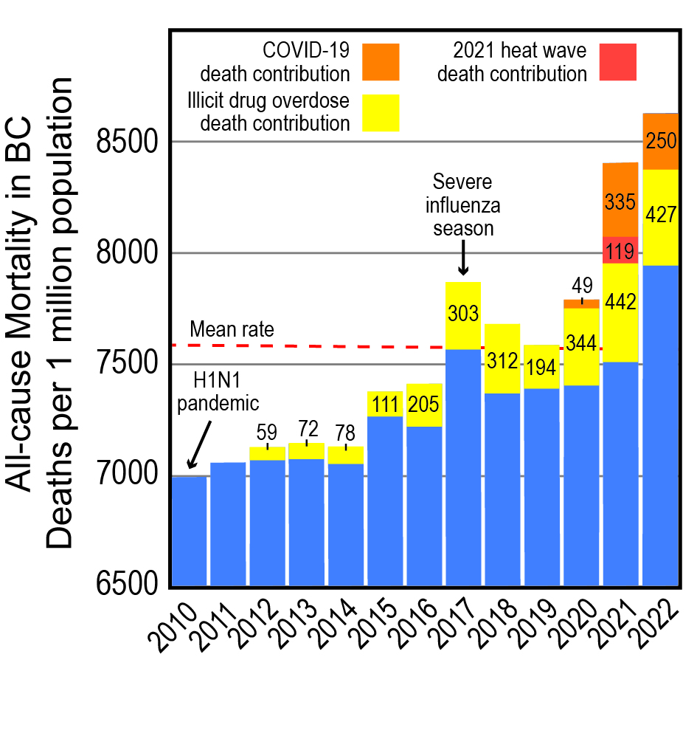

The United Kingdom is one of the few jurisdictions where all-cause and COVID-19 linked mortality has been correlated with COVID-19 vaccination status, age and sex, and this data is available for public scrutiny.65 Graphic representation of the findings are shown in Figure 3. The data indicate that with the emergence of Omicron variants, there has been no real benefit of single or double COVID-19 vaccination for preventing COVID-19 deaths compared to not being vaccinated at all against SARS-CoV-2. There is evidence that triple vaccination might have reduced COVID-19 deaths prior to September 2022, but not significantly afterwards. However, with all-cause mortality (especially with the first dose of the COVID-19 vaccines early in the vaccination program and the second dose subsequently after September 2021), the inoculations are associated with higher rates of death. After May 2022, there is little support that even a third shot of COVID-19 vaccination provided any significant benefit in reducing all-cause mortality. Interpretation of the data in Figure 3 is complicated, since the virulence of the SARS-CoV-2 steadily reduced with the evolution of new variants and increasing natural immunity. In Figure 4, the effects of COVID-19 vaccination on COVID-19-related deaths is specifically shown for the 18-39 years-old age bracket, which would be most relevant to post-secondary students.

Figure 3. UK monthly all-cause and COVID-19 mortality rates from April 1, 2021 to December 31, 2022 as a function of COVID-19 vaccine status.⁶⁵
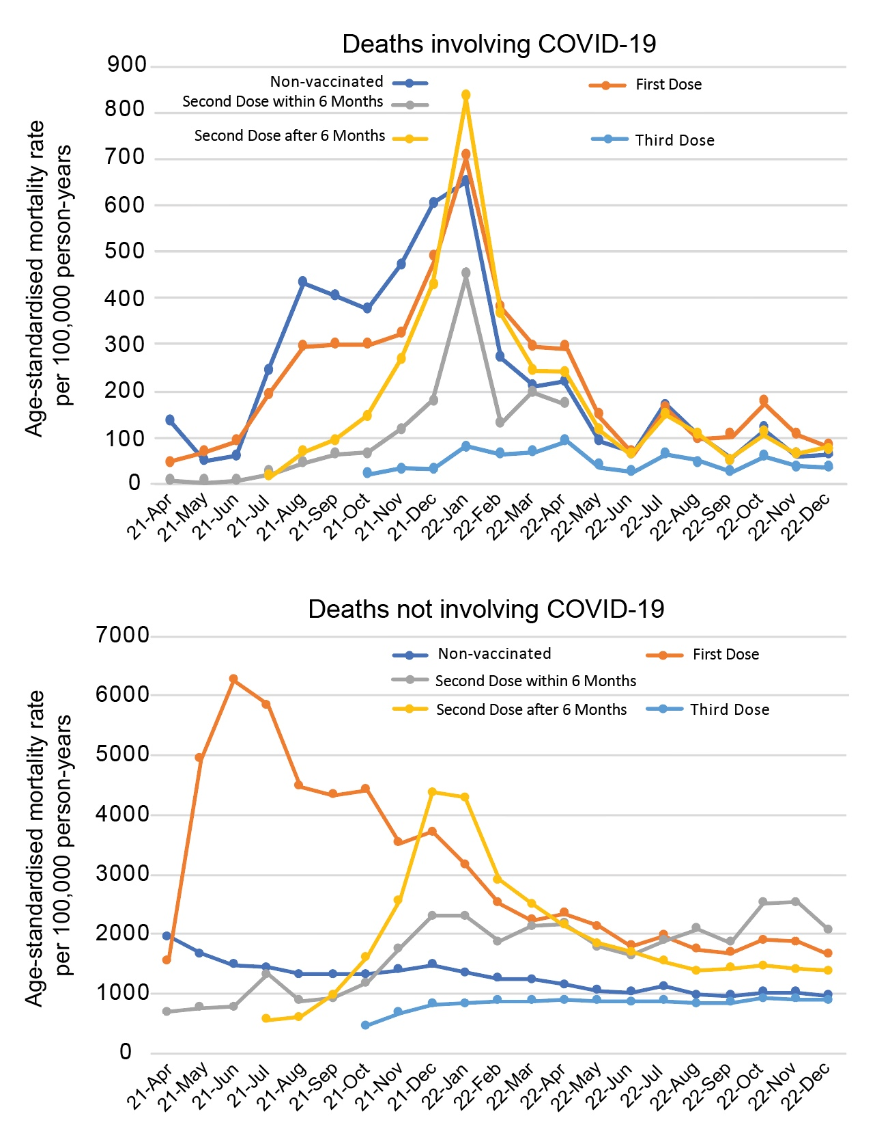

Figure 4. Monthly age-standardized mortality rates by vaccination status by age group for all- cause deaths, deaths involving COVID-19 and deaths not involving COVID-19, per 100,000 person-years, England, deaths occurring between 1 April 2021 and 31 December 2022.⁶⁵ For those that received a second, but not third dose of a COVID-19 vaccine, the death rates prior to June 2022 were between 33 and 71 per 100,000 person-years.
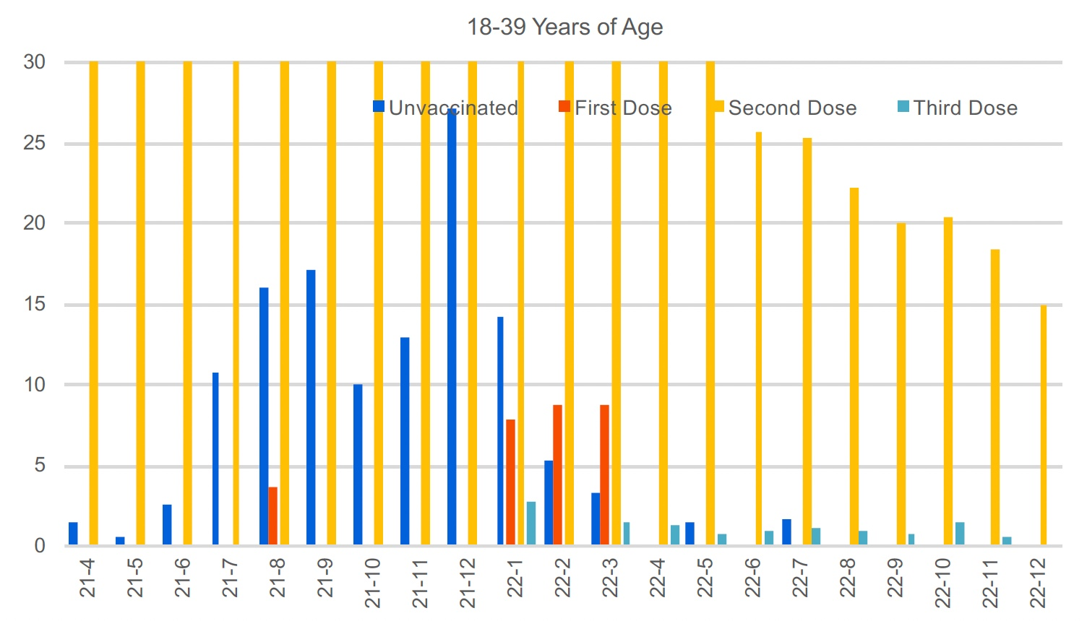

Risk-Benefit Ratio is No Longer Acceptable for COVID-19 Vaccines

Bardosh et al. in a paper entitled, “COVID-19 vaccine boosters for young adults: a risk benefit assessment and ethical analysis of mandate policies at universities” addressed the issue of mandates for university students in North America.66 This study estimated that 31,207 to 42,836 young adults aged 18-19 would need to be vaccinated to prevent just one COVID-19 hospitalization. Also, it was estimated that in those vaccinated to prevent that one COVID-19 hospitalization, at least 18.5 serious adverse events would occur including 1.5–4.6 booster-associated myopericarditis cases in males (typically requiring hospitalisation). The authors stated, “University booster mandates are unethical because they: (1) are not based on an updated (Omicron era) stratified risk-benefit assessment for this age group; (2) may result in a net harm to healthy young adults; (3) are not proportionate: expected harms are not outweighed by public health benefits given modest and transient effectiveness of vaccines against transmission; (4) violate the reciprocity principle because serious vaccine-related harms are not reliably compensated due to gaps in vaccine injury schemes; and (5) may result in wider social harms. We consider counterarguments including efforts to increase safety on campus but find these are fraught with limitations and little scientific support.”⁶⁶

Many Public Health Authorities are No Longer Recommending COVID-19 Vaccination

Countries around the world have begun one after another to discourage or ban the use of COVID-19 vaccines, especially in younger people. Denmark was the first nation in Europe to invoke this step by stopping vaccination invitations on May 14, 2022.67 By autumn 2022, Denmark recommended vaccination only to those over 50 years old and some vulnerable populations.

Many European countries as well as Australia and some US states such as Florida have stopped recommending vaccinations for COVID-19 to anyone under 40, 50 or 60 years of age and especially children. Even in 2021, France and Scandinavian countries did not recommend the Moderna vaccine for people under 30 years of age.68,69 The United Kingdom Joint Committee on Vaccination and Immunisation (JCVI) no longer recommends vaccination of healthy individuals under 50 years of age in the UK except for those in clinical risk groups or those attending to such individuals.70 The Federal Office of Public Health in Switzerland also no longer recommends COVID-19 vaccination for healthy people in all age groups, and will not pay for COVID-19 vaccination for anyone, unless medically indicated by a physician for an individual patient with a clear risk-benefit analysis and the doctor assumes liability for vaccine injury.71 The Australian government has advised that a booster dose is not recommended for children as of February 2023 for children and adolescents up to 18 years who do not have any risk factors for severe COVID-19, and only for those 18-64 years of age who have undergone a risk-benefit analysis with their health care provider.72 The German Federation of Hospitals (DKG) has called for the mandatory vaccination obligation of healthcare personnel to be revoked after the German Ministry of Health admitted that 1 in 5,000 COVID-19 vaccination shots led to serious side-effects.73

Mandatory COVID-19 vaccination is no longer required for Federal government employees in Canada.74 Likewise, it is no longer mandatory for most of the Canadian fighting forces, many of which are similar in age to university students.75

In Ontario, there are currently no government vaccine mandates in effect for any sector, so employers do not have the ability to impose a policy on their health care workers that penalizes them for refusing to be vaccinated, including unpaid leaves of absence and termination for cause. Any policies that attempt to do so are deemed illegal.76 The University of Toronto, for example, only presently has a mandatory COVID-19 vaccine policy for students that are residents on its campus; this mandate should also be terminated.77

In B.C., mandatory COVID-19 vaccination for provincial government employees has also been recently discontinued.78

At this time, the only provincial health ministries in Canada that require mandatory COVID-19 vaccinations of all health care workers are in B.C.79 and Nova Scotia.80 At this time, apart from the University of British Columbia and Dalhousie University, none of the other universities in Canada seem to require mandatory COVID-19 vaccines for their students that are accepted into and enrolled in health care training programs. However, depending on future waves of COVID-19 in the future, this could change.

The lessons learned from the second and third years of the COVID-19 pandemic with the COVID-19 genetic vaccines show that such mandates for students and the general population should not be permitted. We remain concerned that the use of the lipid nanoparticle/mRNA and adenovirus/DNA vaccine technologies are being adopted too rapidly for the replacement of traditional vaccines against common infectious pathogens despite ample evidence demonstrating that they are simply not fit for the purpose. In view of the recent experiences with the COVID-19 genetic vaccines, we warn against any imposition of future vaccine mandates in the absence of compelling data for their long-term efficacy and safety that respects bodily autonomy, human dignity, and informed consent. This includes the right to refuse experimental prophylactic treatments without coercion, extortion and other punitive actions, or permissions requested from unaccountable technocrats ignorant to individual health concerns and values. Universities and other post-secondary institutions that enforce mandatory COVID-19 vaccines are complicit in endangering the long-term health of their students and should instead serve as stalwart defenders of evidence-based research and sensible public policy.

1 Thacker, P.T. (2021) Covid-19: Researcher blows the whistle on data integrity issues in Pfizer’s vaccine trial. BMJ 375:n2635. doi: https://doi.org/10.1136/bmj.n2635
2 Tanveer, S., Rowhani-Farid, A., Hong , K., Jefferson, T., Doshi, P. (2022) Transparency of COVID-19 vaccine trials: decisions without data. BMJ Evid Based Med. 27(4):199-205. doi: 10.1136/bmjebm-2021-111735. https://ebm.bmj.com/content/27/4/199.long
3 Statistics Canada. Table 13-10-0392-01 Deaths and age-specific mortality rates, by selected grouped causes. https://www150.statcan.gc.ca/t1/tbl1/en/tv.action?pid=1310039201 (retrieved April 20, 2023)
4 https://health-infobase.canada.ca/covid-19/vaccination-coverage/ (retrieved April 20, 2023)
5 https://www.cbc.ca/news/politics/omicron-resurgence-booster-dose-1.6507089
6 Tang, J., Sun, J. (2022) Lung tissue-resident memory T cells: the gatekeeper to respiratory viral (re)-infection. Curr Opin Immunol. 80:102278. doi: 10.1016/j.coi.2022.102278. https://pubmed.ncbi.nlm.nih.gov/36565508/
7 https://ourworldindata.org/covid-vaccinations (retrieved April 20, 2023)
8 Morens, D.M., Taubenberger, J.K., Fauci, A.S. (2023) Rethinking next-generation vaccines for coronaviruses, influenza viruses, and other respiratory viruses. Cell Host Microbe. 31(1):146-157. doi: 10.1016/j.chom.2022.11.016. https://pubmed.ncbi.nlm.nih.gov/36634620/
9 https://www.thelancet.com/journals/lanchi/article/PIIS2352-4642%2821%2900066-3/fulltext
10 Public Health Ontario. Confirmed cases of COVID-19 following vaccination in Ontario: December 14, 2020 to January 16, 2022. publichealthontario.ca, 2022. (retrieved January 29, 2022, at https://www.publichealthontario.ca/-/media/documents/ncov/epi/covid-19-epiconfirmed-cases-post-vaccination.pdf?sc_lang=en
11 https://www.cdc.gov/coronavirus/2019-ncov/cases-updates/burden.html (for period February 2020 to September 2021)
12 https://www.publichealthontario.ca/-/media/Documents/nCoV/epi/2023/03/comparison-covid-19-hospitalizations-deaths-epi-summary.pdf
13 https://health-infobase.canada.ca/covid-19/current-situation.html#a5 (retrieved April 8, 2023)
14 https://fcpp.org/2022/09/09/witness-testimony-dr-steven-pelech-professor-department-of-medicine-at-the-university-of-british-columbia-on-natural-immunity/
15 Majdoubi, A., Michalski, C., O’Connell, S.E., Dada, S., Narpala, S. et al. (2021) A majority of uninfected adults show pre-existing antibody reactivity against SARS-CoV-2. JCI Insight 6(8): e14631. https://doi.org/10.1172/jci.insight.146316
16 https://www.cbc.ca/news/canada/edmonton/private-covid-19-antibody-tests-la-crete-alberta-1.6307357
17 Skowronski, D., Kaweski, S. E., Irvine, M.A., Kim, S., Chuang, E.S.Y., et al. (2022) Serial cross-sectional estimate of vaccine and infection-induced SARS-CoV-2 seroprevalence in children and adults, British Columbia, Canada: March 2020 to August 2022. medRxiv preprint doi: https://doi.org/10.1101/2022.09.09.22279751
18 https://www150.statcan.gc.ca/n1/daily-quotidien/230327/dq230327b-eng.htm
19 https://www.thelancet.com/journals/lancet/article/PIIS0140-6736(22)02465-5/fulltext
20 https://www.thelancet.com/journals/lanmic/article/PIIS2666-5247(22)00287-7/fulltext
21 Mallapaty, S. (2021) Decades-old SARS virus infection triggers potent response to COVID vaccines. Nature 596:471-472. doi: https://doi.org/10.1038/d41586-021-02260-9
22 https://pubmed.ncbi.nlm.nih.gov/34351882/
23 Morens, D., Taubenberger, J., and Fauci, A. (2021) Universal coronavirus vaccines – An urgent need. N Engl J Med. 386:297-299. https://www.nejm.org/doi/full/10.1056/NEJMp2118468
24 Becker, K., Becker News, (2021) CDC Director changes her story, now admits COVID vaccines don’t prevent virus transmission. https://beckernews.com/cdc-director-changes-her-story-now-admits-covid-vaccines-dont-prevent-virus-transmission-40754/
25 https://tnc.news/2022/10/18/reuters-fact-check-pfizer/
26 https://www.thelancet.com/journals/laninf/article/PIIS1473-3099(21)00768-4/fulltext
27 Thomas, S.J., Moreira, E.D., Kitchin, N. et al. (2021) Safety and efficacy of the BNT162b2 mRNA COVID-19 vaccine through 6 months. N Engl J Med. 385:1761-1773. https://www.nejm.org/doi/full/10.1056/nejmoa2110345
28 Bridle, B.W., Martins, I., Mallard, B.A., Karrow, N.A., Speicher, D.J., Chaufan, C., Northey, J.G.B., Pelech, S., Shaw, C.A., Halgas, O. (2022) Concerns regarding the efficacy and safety for BNT162b2 mRNA coronavirus disease (COVID-19) vaccine through six months. www.CanadianCovidCareAlliance.org (January 10, 2022) 1-10 https://www.canadiancovidcarealliance.org/wp-content/uploads/2022/01/Final-CCCA-Critique-Thomas-COVID-19-Vaccines-6-months-NEJM-Jan-10-22.pdf
29 http://www.bccdc.ca/health-professionals/data-reports/covid-19-surveillance-dashboard (retrieved May 22, 2022)
30 https://rumble.com/v1tpjsw-deanna-mcleod-why-we-must-stop-the-shots-pt.-1-ineffective-untested-and-uns.html
31 Vogel, G. (2022) Omicron booster shots are coming – with lots of questions. Science. 377(6610):1029-1030. https://www.science.org/content/article/Omicron-booster-shots-are-coming-lots-questions
32 Tin, A. (2022) Why boosted Americans seem to be getting more COVID-19 infections https://www.cbsnews.com/news/covid-19-vaccine-booster-shot-infection-rate/
33 Seneff, S., Nigh, G., Kyriakopoulos, A.M., McCullough, P.A. (2022) Innate immune suppression by SARS-CoV-2 mRNA vaccinations: The role of G-quadruplexes, exosomes, and MicroRNAs. Food Chem Toxicol. 164:113008. doi: 10.1016/j.fct.2022.113008. https://pubmed.ncbi.nlm.nih.gov/35436552/
34 Irrgang, P., Gerling, J., Kocher, K., Lapuente, D., Steininger, P. et al. (2022) Class switch towards non-inflammatory IgG isotypes after repeated SARS-CoV-2 mRNA vaccination. medRxiv. doi: https://doi.org/10.1101/2022.07.05.22277189
35 Follmann, D. Janes, H.E., Buhule, O.D. et al. (2022) Anti-nucleocapsid antibodies following SARS-CoV-2 infection in the blinded phase of the mRNA-1273 Covid-19 vaccine efficacy clinical trial. medRxiv 2022.04.18.22271936; doi: https://doi.org/10.1101/2022.04.18.22271936. Now published in Annals of Internal Medicine doi: 10.7326/m22-1300
36 Buckley, S. (2023) Changes to the drug approval test for COVID-19 vaccines. https://nhppa.org/wp-content/uploads/2023/03/NHPPA-Discussion-Paper-COVID-19-Vaccine-Test-March-17-2023.pdf
37 Gutschi, L.M., Speicher, D.J., Natsheh, S., Oldfield, P., Britz-McKibbon, P. et al. (2022) An independent analysis of the manufacturing and quality issues of the BNT162b BioNTech/Pfizer quasi-vaccine based on the European Medicines Agency’s Public Assessment Report (EPAR). www.canadiancovidcarealliance.org https://www.canadiancovidcarealliance.org/wp-content/uploads/2022/11/22OC29_EMA-Analysis-of-BNT162b-Manufacture.pdf
38 https://campaigns.dailyclout.io/campaign/brand/cc3b3e5a-6536-4738-8ed6-5ee368c67240
39 Pfizer-BioNTech COVID-19 vaccine (BNT162, PF-07302048) Vaccine and Related Biological Products Advisory Committee briefing document (10 December 2020). https://www.fda.gov/media/144246/download#page=87
40 World-wide Safety Pfizer. 5.3.6 Cumulative analysis of post-authorization adverse event reports of PF-07302048 (BNT162N2) received through 28-Feb-2021. https://phmpt.org/wp-content/uploads/2021/11/5.3.6-postmarketing-experience.pdf
41 https://phmpt.org/wp-content/uploads/2021/11/5.3.6-postmarketing-experience.pdf
42 https://pandemictimeline.com/wp-content/uploads/2021/07/Pfizer-report_Japanese-government.pdf
43 Australian Government, Department of Health, Therapeutic Goods Administration. Nonclinical evaluation of BNT162b2 [mRNA] COVID-19 vaccine (Comirnaty™)/ Submission No: PM-2020-05461-1-2. Sponsor: Pfizer Australia Pty Ltd. https://www.tga.gov.au/sites/default/files/auspar-bnt162b2-mrna-210125.pdf
44 https://rumble.com/vxps3a-dr.-arne-burkhardt-pathology-of-covid-19-vaccine-deaths-and-vaccine-injurie.html
45 Chen, Y., Xu, Z., Wang, P., Li, X.-M., Shuai, Z.-W., Ye, D.-Q., Pan, H.-F. (2022) New-onset autoimmune post-COVID-19 vaccination. Immunology. 165(4):386-401. doi: 10.1111/imm.13443. https://pubmed.ncbi.nlm.nih.gov/34957554/
46 Jara, L.J., Vera-Lastra, O., Mahroum, N., Pineda, C., Shoenfeld, Y. (2022) Autoimmune post-COVID vaccine syndromes: does the spectrum of autoimmune/inflammatory syndrome expand? Clin Rheumatol. 41(5):1603-1609. doi: 10.1007/s10067-022-06149-4. https://pubmed.ncbi.nlm.nih.gov/35378658/
47 Moghimi, S.M., Simberg, D. (2022) Pro-inflammatory concerns with lipid nanoparticles. Mol Ther. 30(6):2109-2110. doi: 10.1016/j.ymthe.2022.04.011. https://pubmed.ncbi.nlm.nih.gov/35487214/
48 Scheule, R.K., St George, J.A., Bagley, R.G., Marshall, J., Kaplan, J.M. et al. (1997) Basis of pulmonary toxicity associated with cationic lipid-mediated gene transfer to the mammalian lung. Hum Gene Ther. 8(6):689-707. doi: 10.1089/hum.1997.8.6-689. https://pubmed.ncbi.nlm.nih.gov/9113509/
49 https://vaers.hhs.gov/
50 https://www.openvaers.com/covid-data (retrieved May 1, 2023)
51 Lazarus, R., Klompas, M. (2011) Harvard Pilgrim Study - Lazarus Final Report 2011 | PDF | Electronic Health Record | Adverse Effect. Grant Final Report ID R18 HS 017045. Accessed September 24, 2021. https://www.scribd.com/document/434088983/Lazarus-Final-Report-2011
52 Kirsch, S., Rose, J., Crawford, M. (2021 October 26) Estimating the number of COVID vaccine deaths in America. Trialsite News 57. https://www.skirsch.com/covid/Deaths.pdf
53 Naveed, Z., Li, J., Spencer, M., Wilton, J., Naus, M., García, H.A.V., Otterstatter, M., Janjua, N.Z. (2022) Observed versus expected rates of myocarditis after SARS-CoV-2 vaccination: a population-based cohort study. CMAJ 194:E1529-36. doi: 10.1503/cmaj.220676. https://www.cmaj.ca/content/194/45/E1529
54 Daniels, C.J., Rajpal, S., Greenshields, J.T. et al. (2021) Prevalence of clinical and subclinical myocarditis in competitive athletes with recent SARS-CoV-2 infection: Results from the Big Ten COVID-19 Cardiac Registry. JAMA Cardiol. 6(9):1078-1087. doi:10.1001/jamacardio.2021.2065. https://jamanetwork.com/journals/jamacardiology/fullarticle/2780548
55 Mansanguan, S., Charunwatthana, P., Piyaphanee, W., Dechkhajorn, W., Poolcharoen, A., Mansanguan, C. (2022) Cardiovascular manifestation of the BNT162b2 mRNA COVID-19 vaccine in adolescents. Trop. Med. Infect. Dis. 7, 196. doi: 10.3390/tropicalmed7080196. https://www.mdpi.com/2414-6366/7/8/196
56 Kang, M. (2022) Viral myocarditis. An J. Viral Myocarditis. [Updated 2022 January 5]. In: StatPearls [Internet]. Treasure Island (FL): StatPearls Publishing; Available from: https://www.ncbi.nlm.nih.gov/books/NBK459259/
57 https://makismd.substack.com/p/18-videos-of-collapses-on-stage-and?utm_source=substack&utm_medium=email#play
58 https://goodsciencing.com/covid/athletes-suffer-cardiac-arrest-die-after-covid-shot/
59 https://calgary.ctvnews.ca/deaths-with-unknown-causes-now-alberta-s-top-killer-province-1.5975536
60 Rancourt, D.G. (2022) Probable causal association between India’s extraordinary April-July 2021 excess-mortality event and the vaccine rollout. Correlation Research in the Public Interest. https://correlation-canada.org/report-probable-causal-association-between-indias-extraordinary-april-july-2021-excess-mortality-event-and-the-vaccine-rollout/
61 Rancourt, D.G., Baudin, M. and Mercier, J. (2022) Probable causal association between Australia’s new regime of high all-cause mortality and its COVID-19 vaccine rollout. Correlation Research in the Public Interest. https://correlation-canada.org/report-probable-causal-association-between-australias-newregime-of-high-all-cause-mortality-and-its-covid-19-vaccine-rollout/
62 Rancourt, D.G., Baudin, M., Hickey, J. and Mercier, J. (2023) Age-stratified COVID-19 vaccine-dose fatality rate for Israel and Australia. Correlation Research in the Public Interest. https://correlation-canada.org/report-age-stratified-covid-19-vaccine-dose-fatality-rate-for-israel-and-australia/
63 Aarstad, J., Kvitastein, O.A. (2023) Is there a link between the 2021 COVID-19 vaccine uptake in Europe and 2022 excess all-cause mortality? doi:10.20944/preprints202302.0350.v1 https://www.preprints.org/manuscript/202302.0350/v1
64 Data sourced from https://bccdc.shinyapps.io/Mortality_Context_ShinyApp/ and https://www2.gov.bc.ca/gov/content/lifeevents/death/coroners-service/statistical-reports (retrieved February 24, 2023)
65 Data source from Deaths occurring between 1 April 2021 and 31 December 2022 edition. https://www.ons.gov.uk/peoplepopulationandcommunity/birthsdeathsandmarriages/deaths/datasets/deathsbyvaccinationstatusengland (retrieved April 1, 2023)
66 Bardosh, K., Krug, A., Jamrozik, E., Lemmens, T., Keshavjee, S. et al. (2022) COVID-19 vaccine boosters for young adults: a risk benefit assessment and ethical analysis of mandate policies at universities. Journal Medical Ethics. doi: 10.1136/jme-2022-108449. https://jme.bmj.com/content/early/2022/12/05/jme-2022-108449
67 https://www.msn.com/en-in/money/topstories/covid-19-denmark-currently-not-offering-booster-shots-to-those-under-50/ar-AA11TTwi
68 https://www.france24.com/en/live-news/20211109-france-advises-against-moderna-for-under-30s-over-rare-heart-risk
69 Lehto, E. (2021) Finland joins Sweden and Denmark in limiting Moderna COVID-19 vaccine. https://www.reuters.com/world/europe/finland-pauses-use-moderna-covid-19-vaccine-young-men2021-10-07/
70 https://www.gov.uk/government/publications/covid-19-vaccination-programme-for-2023-jcvi-interim-advice-8-november-2022/jcvi-statement-on-the-covid-19-vaccination-programme-for-2023-8-november-2022
71 https://www.bag.admin.ch/bag/en/home/krankheiten/ausbrueche-epidemien-pandemien/aktuelle-ausbrueche-epidemien/novel-cov/impfen.html#21889874
72 https://www.health.gov.au/our-work/covid-19-vaccines/advice-for-providers/clinical-guidance/clinical-recommendations
73 https://rairfoundation.com/german-hospital-federation-demands-withdrawal-of-vaccination-mandate-after-massive-side-effects-revealed/
74 https://www.canada.ca/en/treasury-board-secretariat/news/2022/06/suspension-of-the-vaccine-mandates-for-domestic-travellers-transportation-workers-and-federal-employees.htmle
75 https://www.ctvnews.ca/politics/military-eases-vaccine-mandate-presses-ahead-with-discipline-for-unvaccinated-troops-1.6108910
76 https://stlawyers.ca/coronavirus-knowledge-centre/employer-mandatory-vaccinations/ontario/
77 https://www.viceprovoststudents.utoronto.ca/covid-19/
78 https://news.gov.bc.ca/releases/2023FIN0018-000305
79 https://www2.gov.bc.ca/assets/gov/health/about-bc-s-health-care-system/office-of-the-provincial-health-officer/hospital_and_community_preventive_measures_order_apr_623_final_4.pdf
80..https://policy.nshealth.ca/Site_Published/nsha/document_render.aspx?documentRender.IdType=6&documentRender.GenericField=&documentRender.Id=99848

